# *Lab 2 – Analysis of Agile Methodologies*

Date assigned: Monday, January 30, 2017

Date due: **Monday, January 30, 2017, 4:50pm**

**Learning Objectives**

Upon successful completion of this lab exercise, the student will be able to:

* Understand the basic concepts of Agile
* Understand the basic concepts of Scrum
* Understand how DAD compares to Scrum as an alternative Agile methodology

**Marks**

|  |  |  |  |
| --- | --- | --- | --- |
| Section | Question | Mark | Effort (minutes) |
| 1. Scrum Process Diagram (Team work) | Includes all project collateral/items | 4 | 0 |
|  | Shows all proper timeframes/events | 4 | 0 |
|  | Proper sequencing | 4 | 0 |
|  | Design (understandable not no more complex than it has to be) | 2 | 0 |
| 1. General Agile | 1 | 2 | 0 |
|  | 2 | 2 | 0 |
|  | 3 | 2 | 0 |
|  | 4 | 2 | 0 |
| 1. Scrum process | 1 | 2 | 0 |
|  | 2 | 4 | 0 |
|  | 3 | 4 | 0 |
|  | 4 | 4 | 0 |
|  | 5 | 4 | 0 |
|  | 6 | 4 | 0 |
|  | 7 | 3 | 0 |
|  | 8 | 3 | 0 |
| 1. Scrum process | 1 | 2 | 0 |
|  | 2 | 4 | 0 |
|  | 3 | 4 | 0 |
|  | 4 | 4 | 0 |
| English and handed in properly |  | 5 | 0 |
| Totals |  | 69 | 0 |

Lab Set Up

1. Rename this document called *YourUsername*_E21_L02.docx.
2. Research from class notes and online to answer the questions from this lab in this document.
3. Include your effort tracking for each section (or just fill in the total. I just need a rough understanding of the effort required for this lab.

To do:

## **Part A – Scrum Process Diagram**

Group work. HVK Teams, Assemble! (i.e. Get together with your HVK Team.)

Create a diagram (from scratch, do not copy an already completed diagram) that shows the Scrum Sprint lifecycle/process. I do not care which tools you use, this could be a picture of a whiteboard drawing.

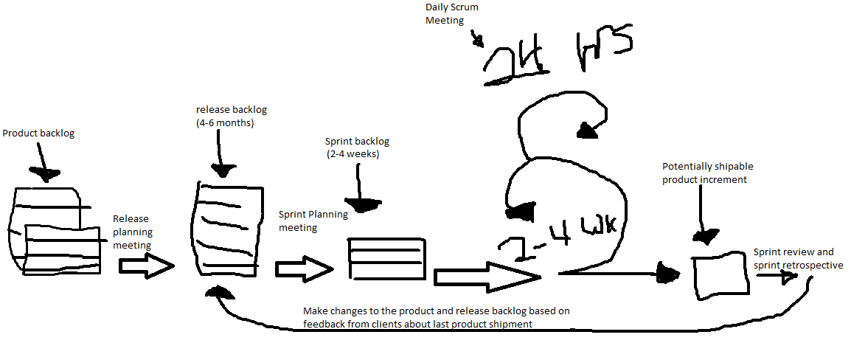

It must show the following project collateral/items:

1. Product Backlog
2. Release Backlog
3. Sprint Backlog
4. Potentially shippable product increment

It must show the following timeframes and events

1. A product has several Releases
2. A Release has several Sprints
3. A Sprint has daily Scrum meetings
4. A Sprint has a Sprint planning meeting at the beginning of each Sprint
5. A Sprint has a Sprint Review and a Sprint Retrospective at the end of each Sprint

The rest of this lab (Part B,C,D) is an individual lab. Bid you team mates “farewell and god speed” and strike out on your own path.

## **Part B – General Agile**

Read the Agile Manifesto and select from column A or column B, which is the priority for Agile

|  |  |  |  |
| --- | --- | --- | --- |
| Column A | Column B | Higher priority for Agile  (Choose A/B) | Agile Manifesto item  (Put the one-liner from the Agile Manifesto here) |
| Frequent collaboration with the product owner to get feedback | Well-defined contract defining the deliverables | A | **Customer collaboration** over contract negotiation |
| Proper use of process and tools | Proper use of people and proper interactions | B | **Individuals and interactions** over processes and tools |
| Adapt to changing requirements and environment | Well defined plan and disciplined adherence to the plan throughout the project | A | **Responding to change** over following a plan |
| Through documents explaining the final product early in the process | Incremental, demonstrable software | B | **Working software** over comprehensive documentation |

## **Part C – Scrum Process**

Navigate to the link <http://www.mountaingoatsoftware.com/scrum> and use it and subsequent linked pages for the following questions.

1. When is it ideal to have a Scrum project (i.e use the Scrum methodology)?

When your user requirements are constantly changing and you don’t have much information. If your client wants to stay involved in the development through the entire process.

1. Describe the role of the Scrum Master. According to the articles, what are six qualities of a good Scrum Master?

The scrum master is the “team coach”, helping team members use the scrum process to perform at the highest level.

1. What is the difference between a sprint backlog and a product backlog?

A product backlog is the entirety of what the current vision of the final product has to contain. It’s written in user stories and encompasses multiple different sprints until a final product is built or will change enough that it will never be finished.

1. What is the difference between a sprint backlog and a sprint burndown?

A sprint backlog is the work that needs to get done throughout an entire sprint, whereas a spring burndown is a chart of everything that is left to do at any given point in a sprint. This way you can know if you’re on track to finishing the sprint on time.

1. What is the difference between a Sprint burndown and a Release burndown?

A release burndown is the same as a sprint burndown, but for an entire release of the product. So a release is a 4-6 month period and a release burndown is everything that needs to be finished for a given release.

1. What is and isn’t a Daily scrum used for? What affect does it have on the members of the team?

A daily scrum meeting is used to inform the team what has been done, what needs to be done, and gives everyone an opportunity to share anything that they might need help with. It’s to make sure everyone is on the same page about where they’re at.

1. What is the primary role of the Product Owner in a Scrum/Sprint process?

The product owner is the driver of the sprint’s goals, making sure they’re always moving in the right direction.

1. What is the definition of a “Sprint Goal”? When and how do you evaluate a Sprint Goal?

A sprint goal is a short, one- or two-sentence, description of what the team plans to achieve during the sprint. It is written collaboratively by the team and the product owner.

## **Part D – DAD**

Navigate to the link <http://www.disciplinedagiledelivery.com/introduction-to-dad/> and use it and subsequent linked pages for the following questions.

1. What does the acronym DAD stand for?

Disciplined Agile Delivery

1. Why would an organization choose DAD over Scrum?

Because Scrum methodologies are as scalable and don’t cover larger scale more complex projects.

1. What are the roles in DAD? What is the difference between Primary and Secondary roles? Why does DAD have more roles than Scrum?

Primary Roles

* Team Lead
* Product owner
* Team member
* Architecture owner
* Stakeholder

Secondary Roles

* Specialist
* Independent tester
* Domain expert
* Technical Expert
* Integrator

The primary roles in a DAD methodology are roles that have more immediate investment in the product. The product owner, architecture owner, stakeholders, etc., they all have a personal investment in the product’s success. They’re also the ones that make the final decisions on things. The secondary roles are the technical experts, they advise the primary roles and are the ones who will build the product.

The primary issue is one of scope.  Scrum mostly focuses on leadership and change management aspects during Construction and therefore has roles which reflect this.  DAD on the other hand explicitly focuses on the entire delivery lifecycle and all aspects of solution delivery, including the technical aspects that Scrum leaves out.  So, with a larger scope comes more roles.

1. What is the definition of “Enterprise awareness” in DAD? Provide two reasons as to why this is important.

Enterprise awareness is each different DAD team being aware of the work of other teams throughout the enterprises ecosystem. This is important to make sure that different potentially shippable product increments integrate well with eachother and with the rest of the system. They also allow you to cut costs by each DAD team being able to use the work that’s been completed by other teams.